**SAP Client Copy: Local, Remote, Import/Export**

**Client Copy**

We can generate a blank client with SCC4.***But how to fill the data in the client?* "Answer is the client copy."**

Client copy means "**transferring client specific data"**within the same instance(SID) or between different instances(SID).

Client copy can be performed with three different methods -

1. Local client copy.
2. Remote client copy.
3. Client Import/Export.

Below brief details are given about client copy methods.

**Local Client Copy: -** This method is used to copy client within the same instance (SID).It is done by T-code **SCCL**.

[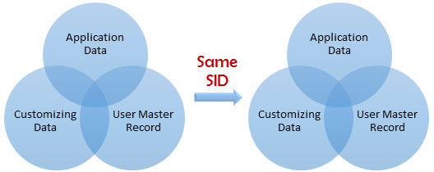](https://www.guru99.com/images/sap/2013/02/ClientCopysameSID.jpg)

**Remote Client Copy: -**This method is used to copy client between different instances(SID).It is performed by T-code SCC9.

[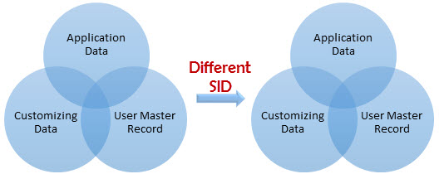](https://www.guru99.com/images/sap/2013/02/ClientCopyDifferentSID.jpg)

**Client Import/Export: -**This method is used to copy client between different instances(SID).It is performed by T-code **SCC8**

**Client Copy Pre-steps**

To avoid data **inconsistencies** there are few pre-steps to be performed before starting client copy:-  
**1) Disconnect and lock business users(SU10).**You can end the session of active users in the system through **SM04.**Once all users are logged out, check that no canceled or pending update requests exist in the system.

[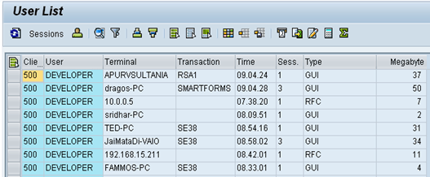](https://www.guru99.com/images/sap/2013/02/022613_0657_Introductio14.png)

**2) Suspend all background jobs**

* Execute **SE38**as given below**.**

[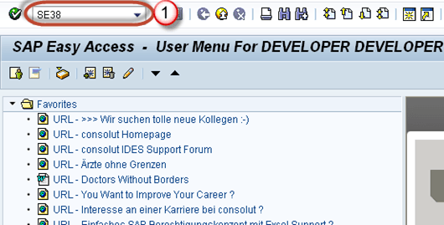](https://www.guru99.com/images/sap/2013/02/022613_0657_Introductio15.png)

* Fill program name with "BTCTRNS1" as above figure.
* Press Execute.

[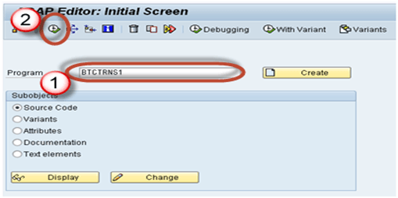](https://www.guru99.com/images/sap/2013/02/022613_0657_Introductio16.png)

**3)  For a local copy, the system must have enough space in the database or tablespace**.  
For remote copy, target system must have enough space in the database or tablespace. Check space using Tx **DB02.**

[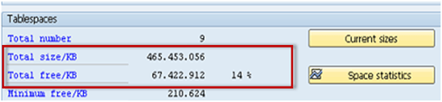](https://www.guru99.com/images/sap/2013/02/022613_0657_Introductio17.png)

**4)** To avoid inconsistencies during client copy users should not be allowed to work in source client.  
  
**5) rdisp/max_wprun_time** parameter should be changed to 2000 second as a SAP recommendation . Although you use parallel processes and schedule job in the background, dialog processes will be used. **(This can be ignored for now)**

**Local Client Copy**

Local client copy is performed using **Tcode SCCL.**  
**Scenario:-**

* Source Instance & client := DKM-000
* Target Instance & client := DKM-202

**Step 1)** Create an entry for your new target client using **SCC4**. In our scenario, we will create client 202 in DKM system.Log on to this newly created target client (**DKM-202**) with user SAP* and default password pass.  
  
**Step 2)** Excute T-code **SCCL.**

[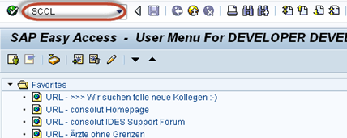](https://www.guru99.com/images/sap/2013/02/022613_0657_Introductio18.png)

**Step 3)**

* Select your desired profile
* Enter Source client.
* Enter Description

[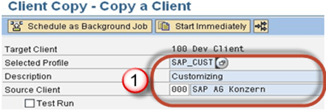](https://www.guru99.com/images/sap/2013/02/022613_0657_Introductio19.png)

**Step 4)** By default Client Copy is executed as a single process. A Single process will take a lot of time. We will distribute the workload of single the process to parallel(multiple) processes which will reduce time in copying a client.

1. Select **Goto** from the menubar.
2. Select **Parallel Process**.Parallel processes are used to exploit the capacity of database better

[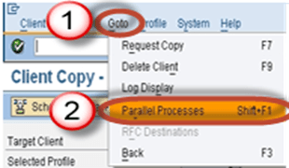](https://www.guru99.com/images/sap/2013/02/022613_0657_Introductio21.png)

**Step 5)**Always execute long running processes in background mode rather than foreground/dialog mode. In fact, some processes run more quickly in the background.

[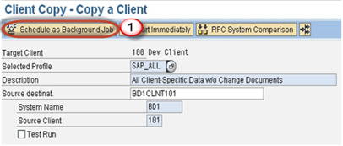](https://www.guru99.com/images/sap/2013/02/022613_0657_Introductio22.png)

**Step 6)** The client copy logs are available in **SCC3**. Status - "**Successfully Completed"**means client copy is completed.

[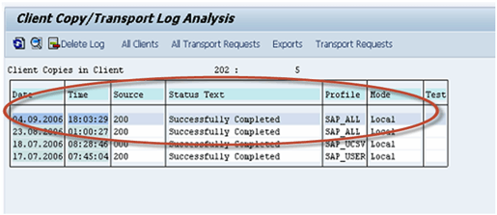](https://www.guru99.com/images/sap/2013/02/022613_0657_Introductio23.png)

**Remote Client Copy:-**

This technique uses Remote function call. You can view RFC from SM59. This technique depends on the network, so network connectivity must be strong enough.  
  
**Scenario:-**  
Source Instance & client := **BD1-101**  
Target Instance & client := **DKM-202**  
**Step 1)** Log on to the target system. Here we will log on to DKM system. Create a new target client entry(202) using **SCC4.**Log on to this new target client with user **SAP\*** and default password "**pass**".Here we will log on to DKM-200 system.  
  
**Step 2)**Execute Transaction Code SCC9.

**[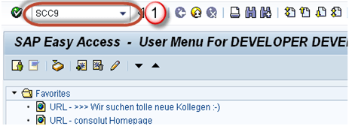](https://www.guru99.com/images/sap/2013/02/022613_0657_Introductio24.png)**

**Step 3)**Fill the basic details as per your requirement.

[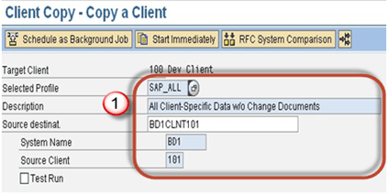](https://www.guru99.com/images/sap/2013/02/022613_0657_Introductio25.png)

**Step 4)** Select Parallel Process.Parallel processes are used to exploit the capacity of database better.

[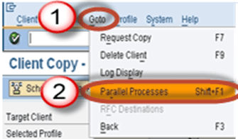](https://www.guru99.com/images/sap/2013/02/022613_0657_Introductio28.png)

**Step 5)** Schedule the client copy in background

[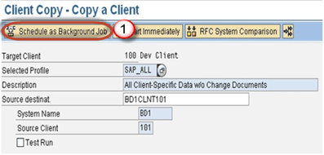](https://www.guru99.com/images/sap/2013/02/022613_0657_Introductio29.png)

**Step 6)** The client copy logs are available in **SCC3**as given below.

[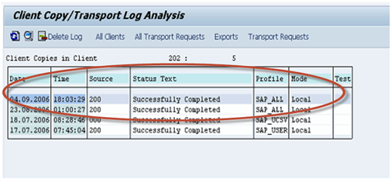](https://www.guru99.com/images/sap/2013/02/022613_0657_Introductio30.png)

**Client Import/Export**

For large database, it is recommended to use client import/export instead of remote client copy.  
**Scenario:-**  
Source Instance & client := **PKT-300**  
Target Instance & client := **DKM-202**  
This technique always starts with client ***export*** step.  
  
**Note**: - You must have enough space in the /usr/sap/trans_SID file system to perform the client export.

**How to export client?;**

**Step 1)** Log on to the target system(DKM). Create an entry for your new target client using **SCC4.** Log on to the source system/source client(PKT).  
  
**Step 2)Before you import a Client you need to export**.Export is nothing but transferring data files and co-files from source system's database to target system's import buffer.Execute T-code**SCC8.**

[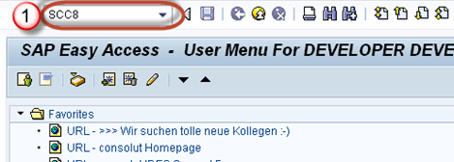](https://www.guru99.com/images/sap/2013/02/022613_0657_Introductio31.png)

**Step 3)**

* Select profile
* Choose target system.

[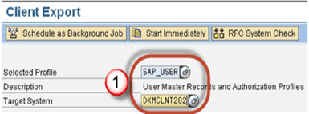](https://www.guru99.com/images/sap/2013/02/022613_0657_Introductio32.png)

**Step 4)** Schedule the export in background

[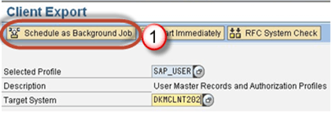](https://www.guru99.com/images/sap/2013/02/022613_0657_Introductio33.png)

**Step 5)** Once the job is executed  data files and co-files of profiles from **PKT system's database are transferred to DKM** system's import buffer.Once we will import request in DKM only then it will be reflected in a database of **DKM** system.  
  
Depending on the chosen export profile there can be up to 3 transport requests created:

* Request PKTKO00151 will hold the cross-client data,
* Request  PKTKT00151 will hold the client dependent data,
* Request  PKTKX00151 will also hold some client dependent data.

**How to import the client?**

**Step 1)** Log on to the newly created target client(DKM-202) using SAP* and password pass.  
  
**Step 2)** Start the **STMS_IMPORT**transaction

[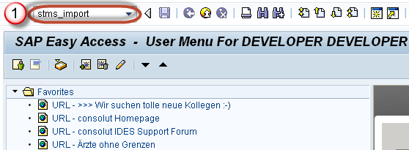](https://www.guru99.com/images/sap/2013/02/022613_0657_Introductio34.png)

As shown below, import queue will open

[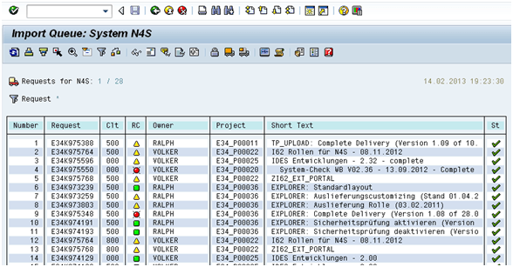](https://www.guru99.com/images/sap/2013/02/022613_0657_Introductio35.png)

**Step 2)** Select the transport requests generated by client export .Import theses transport requests on the target client.  
  
The transport requests should be imported in the following sequence:

1. Request PKTKO00151
2. Request  PKTKT00151
3. Request  PKTKX00151

The system automatically detects these are client export transport requests and automatically performs the import of the 3 requests.  
The import logs can be seen in **STMS_IMPORT.**

[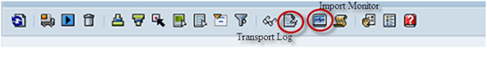](https://www.guru99.com/images/sap/2013/02/022613_0657_Introductio36.png)

**Step 3) Post import phase:-**  
Once the import is done, execute **SCC7**  to perform the post client import actions,

[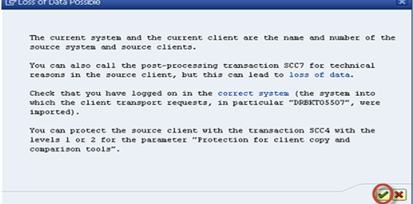](https://www.guru99.com/images/sap/2013/02/022613_0657_Introductio37.png)

Schedule the post import job in background.

[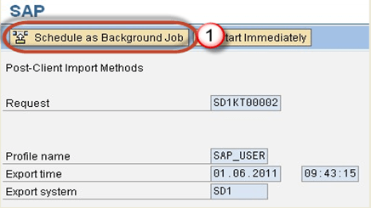](https://www.guru99.com/images/sap/2013/02/022613_0657_Introductio38.png)

**Step 4)** Import log will be available in **SCC3.**The Client is successfully imported.